2602070383 – Bernard Bereness  
LC01

ConnectFriend Documentation

**Main Features**

1. **[LO1,LO2,LO3 & LO4, 20 points]** User Authentication

Register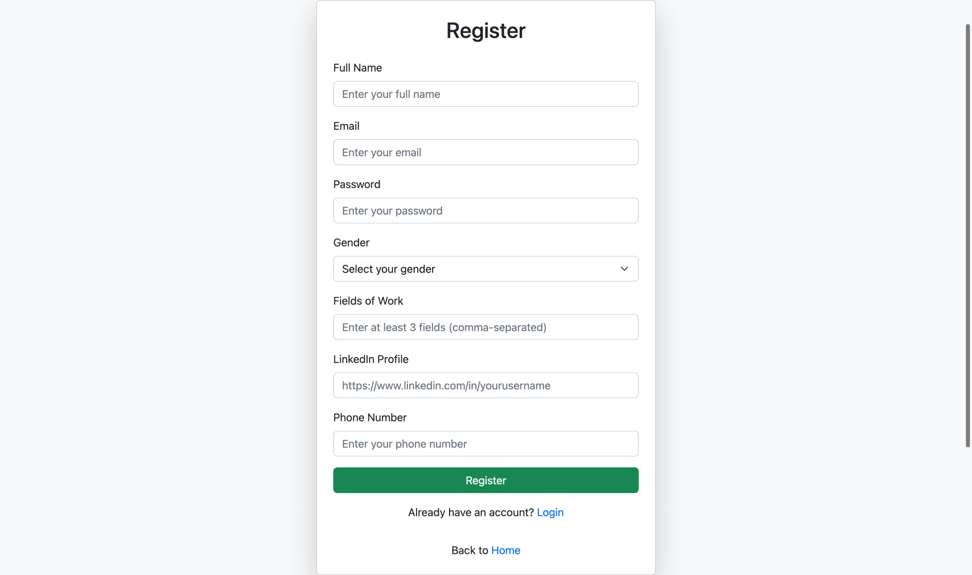

Register Validation  
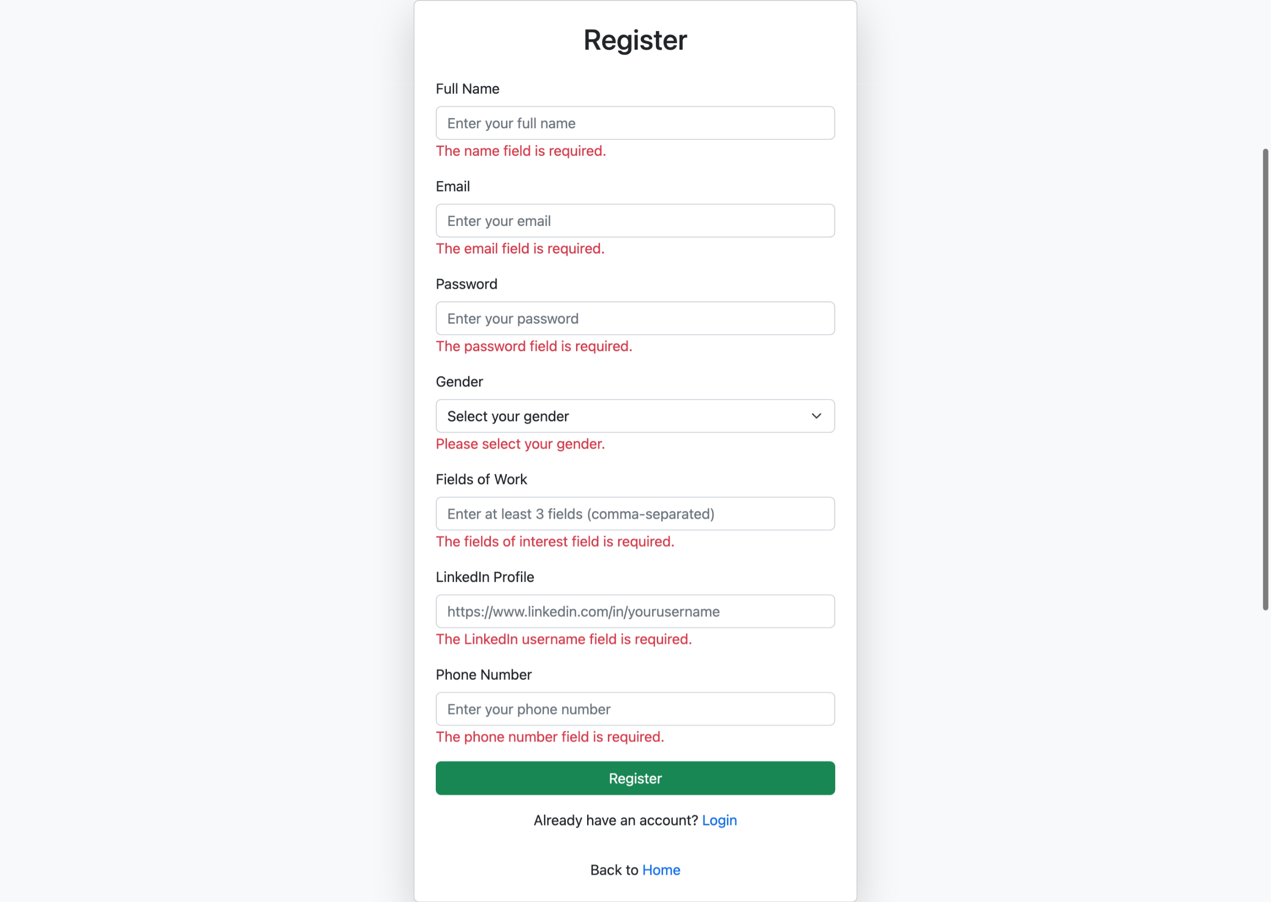

Login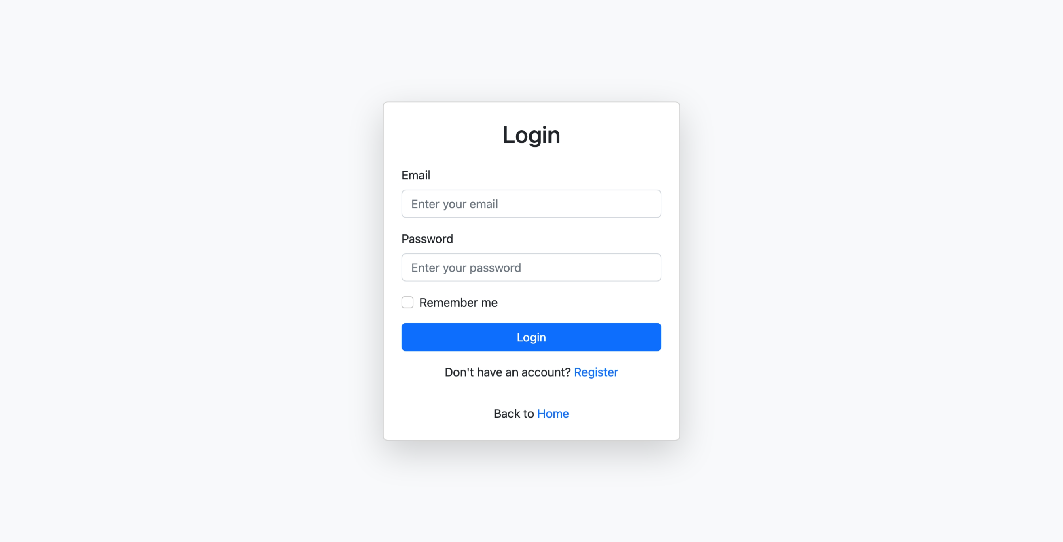

Login (Register Successfully)  
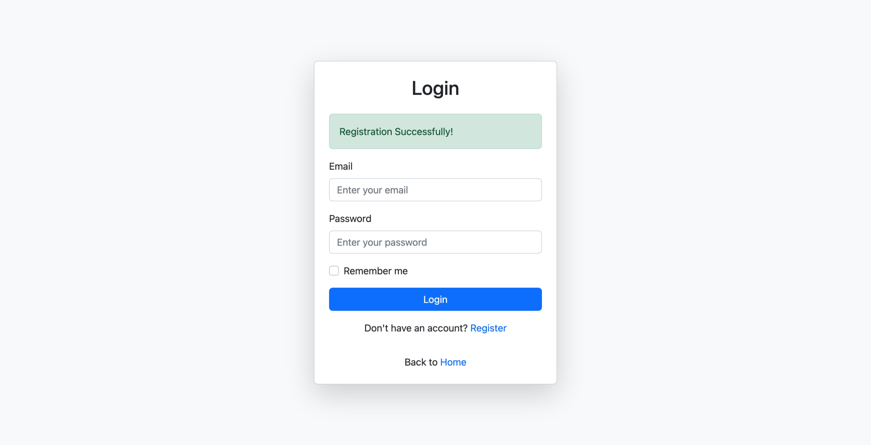

1. **[LO1,LO2,LO3 & LO4, 10 points]** Payment

Payment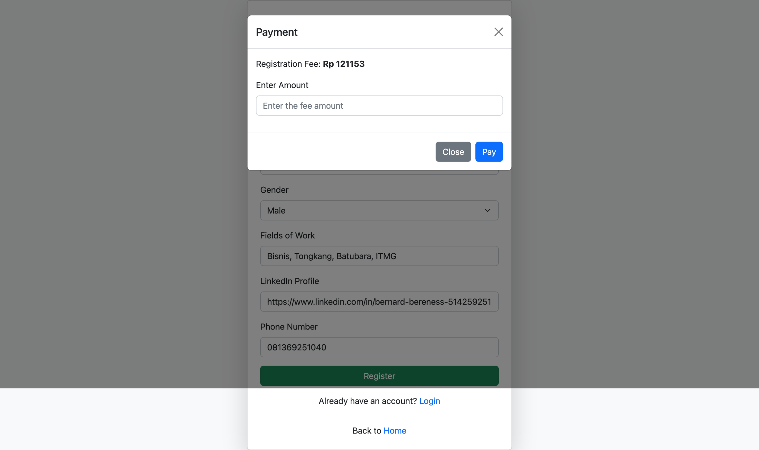

Overpaid Payment  
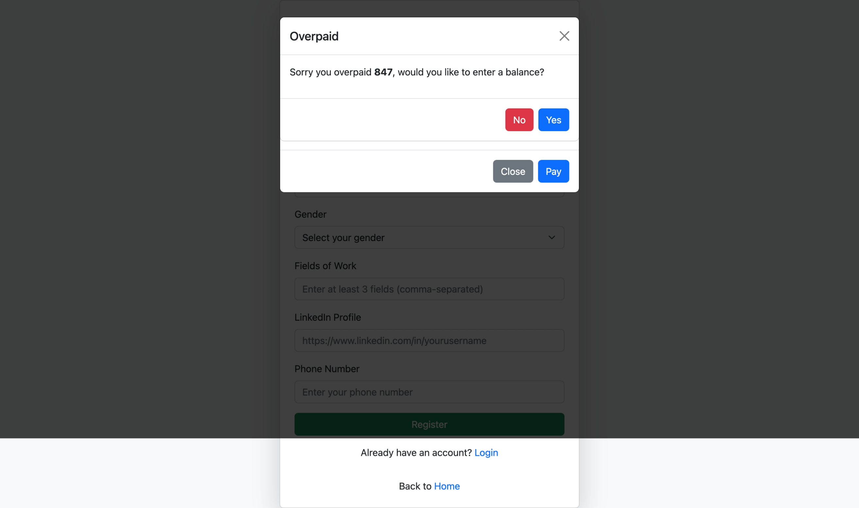

Underpaid Payment  
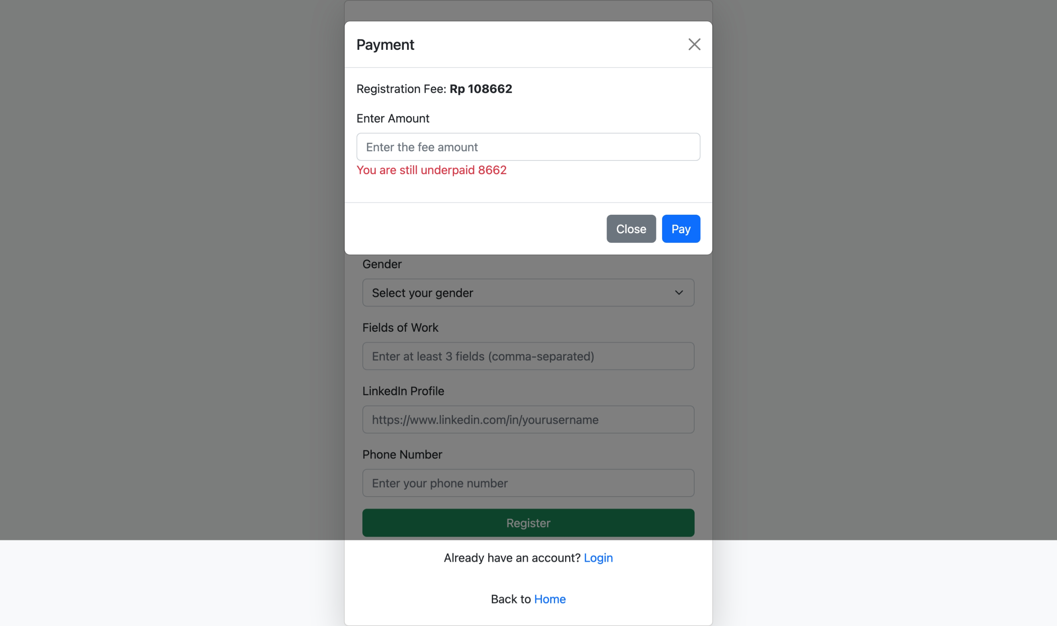

1. **[LO1,LO2,LO3 & LO4, 30 points]** Friends

Friends  
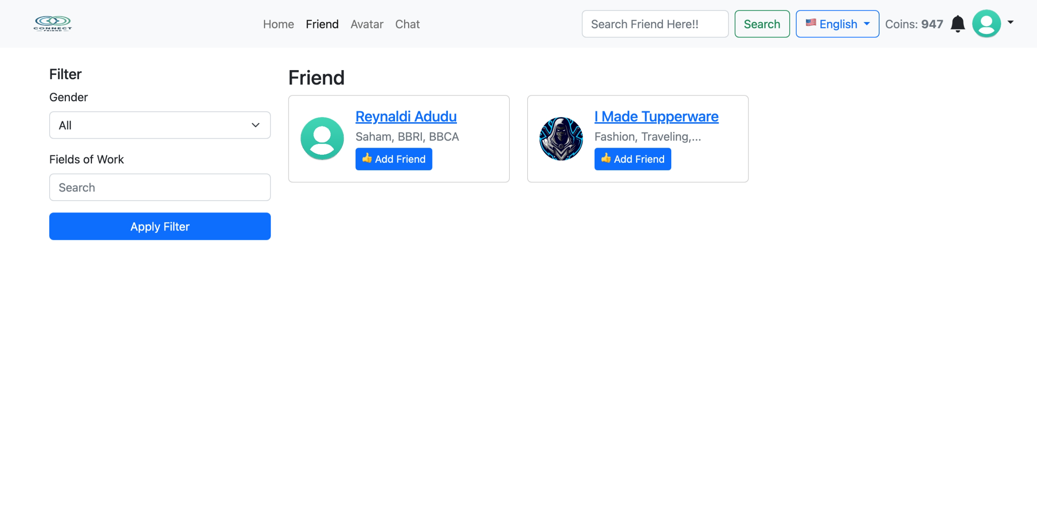

Pending Friend Request  
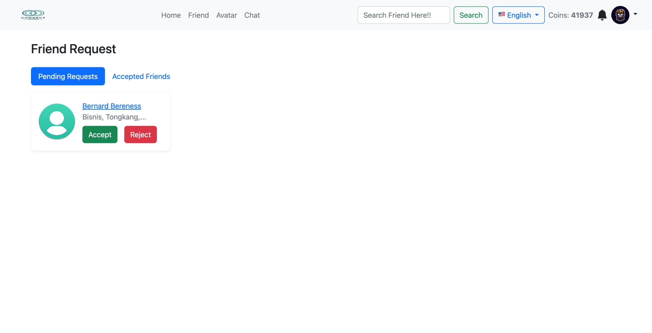

Accepted Friends  
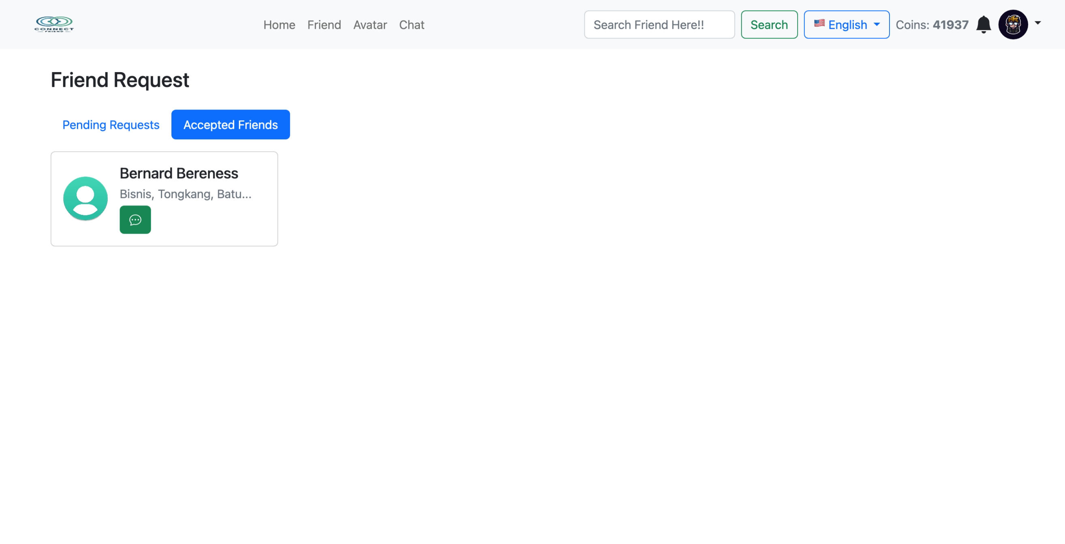

1. [**LO1,LO2,LO3 & LO4, 20 points]** Messaging/Video Call

Chat  
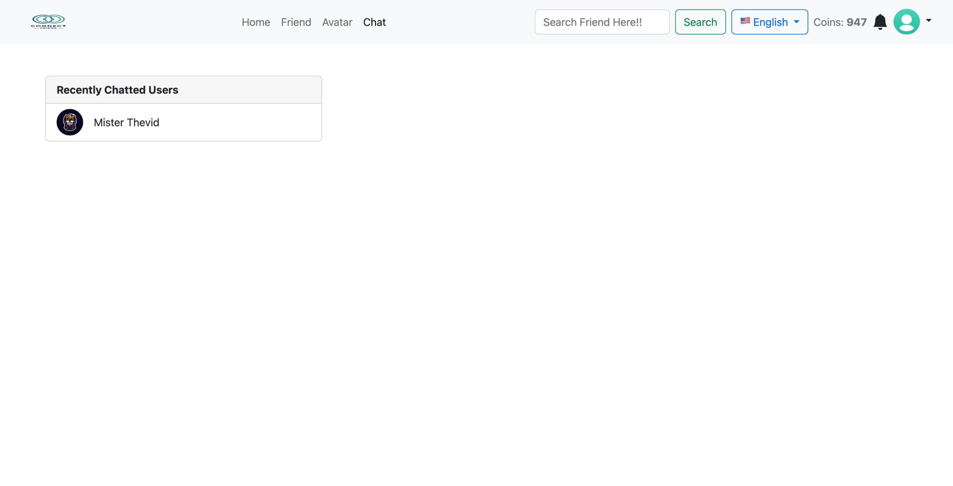  
  
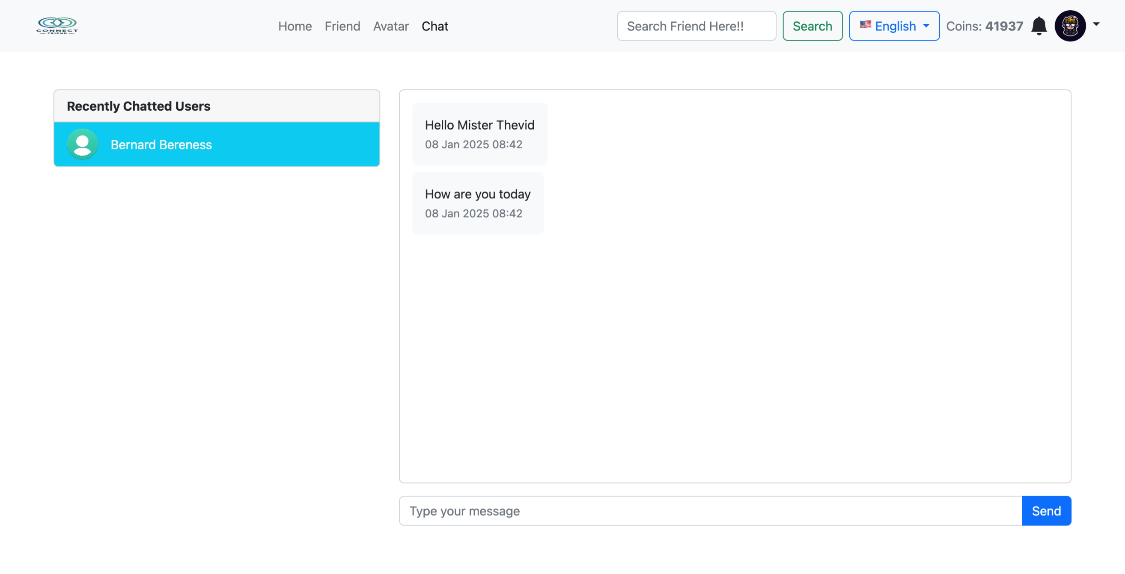

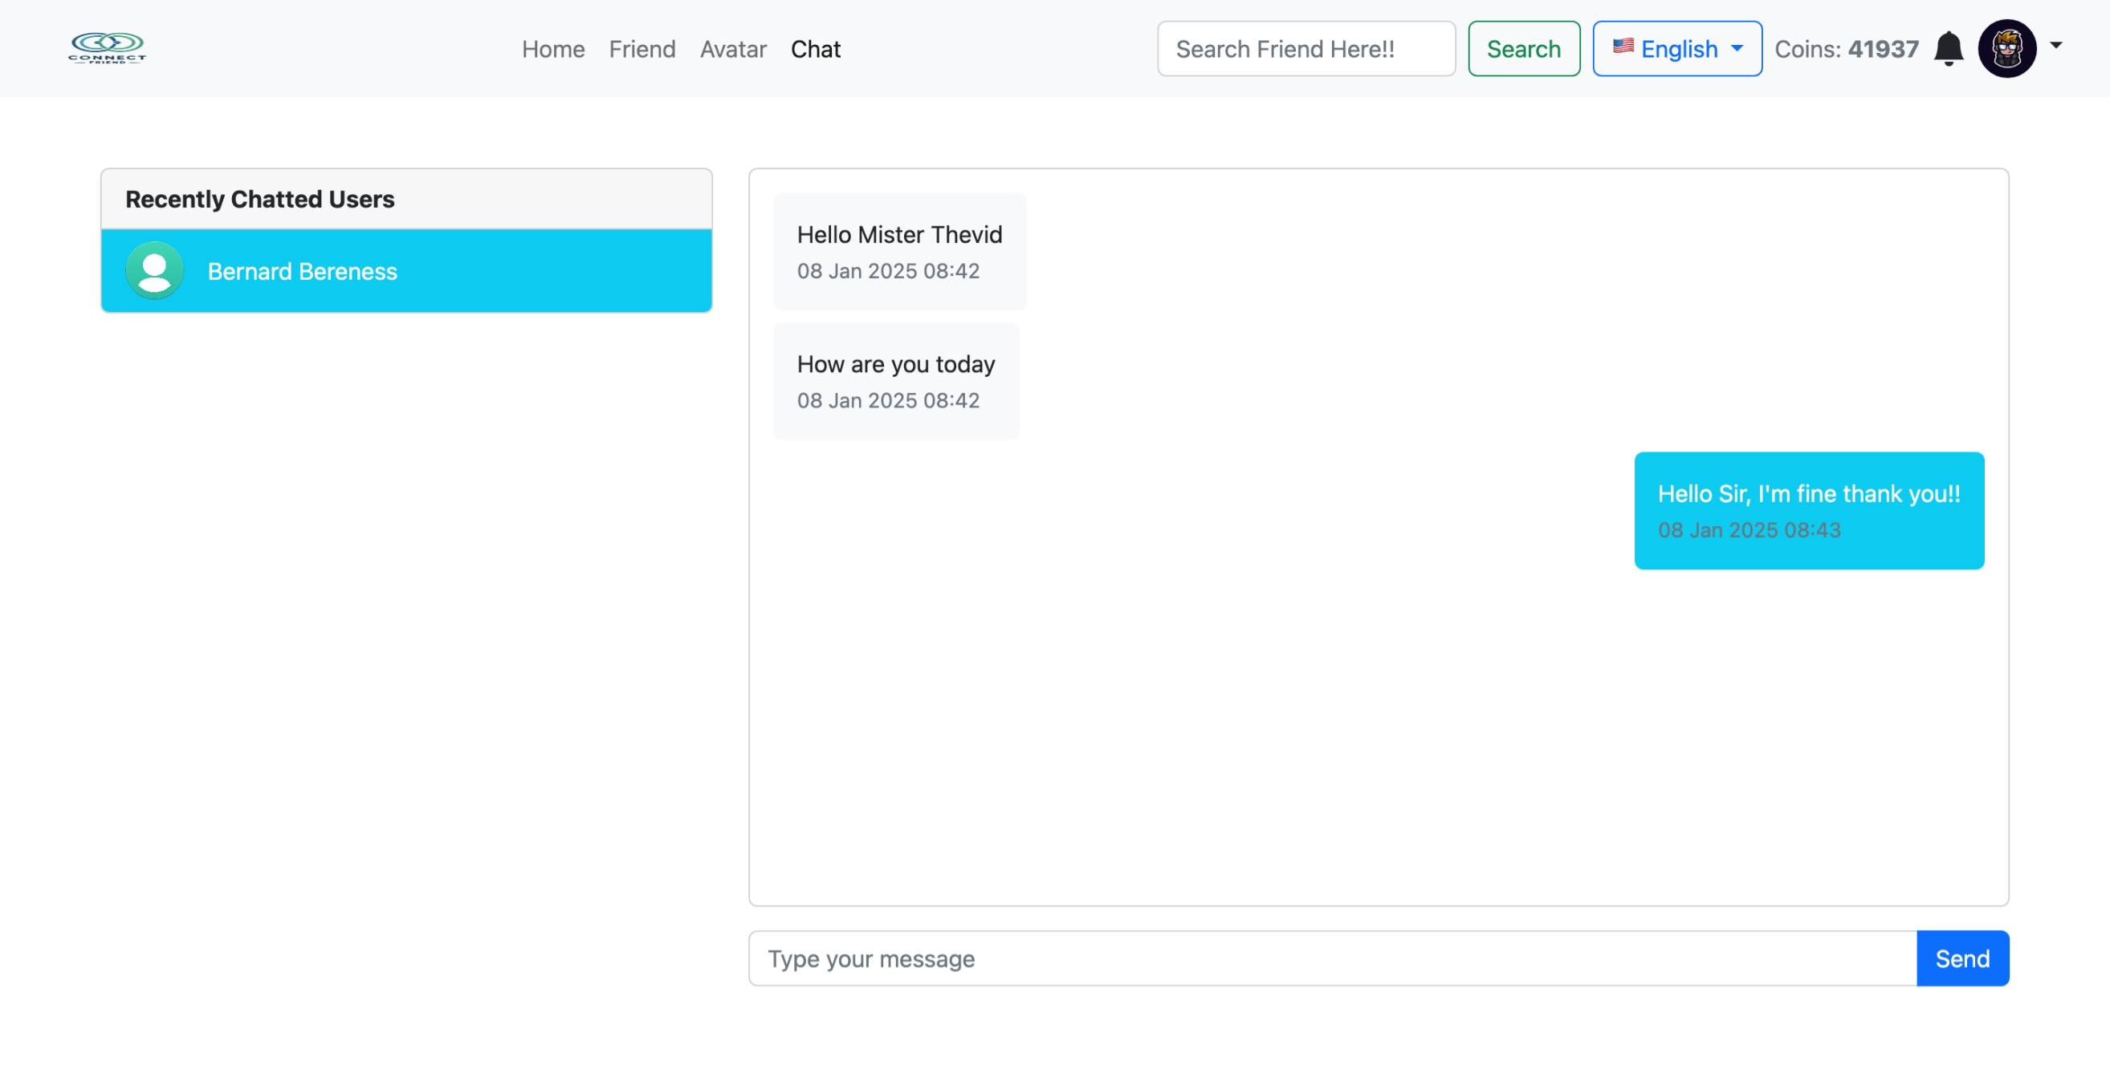

1. **[LO1,LO2,LO3 & LO4, 10 points]** Searching & Filtering

Searching (Job) & Filtering (Gender) 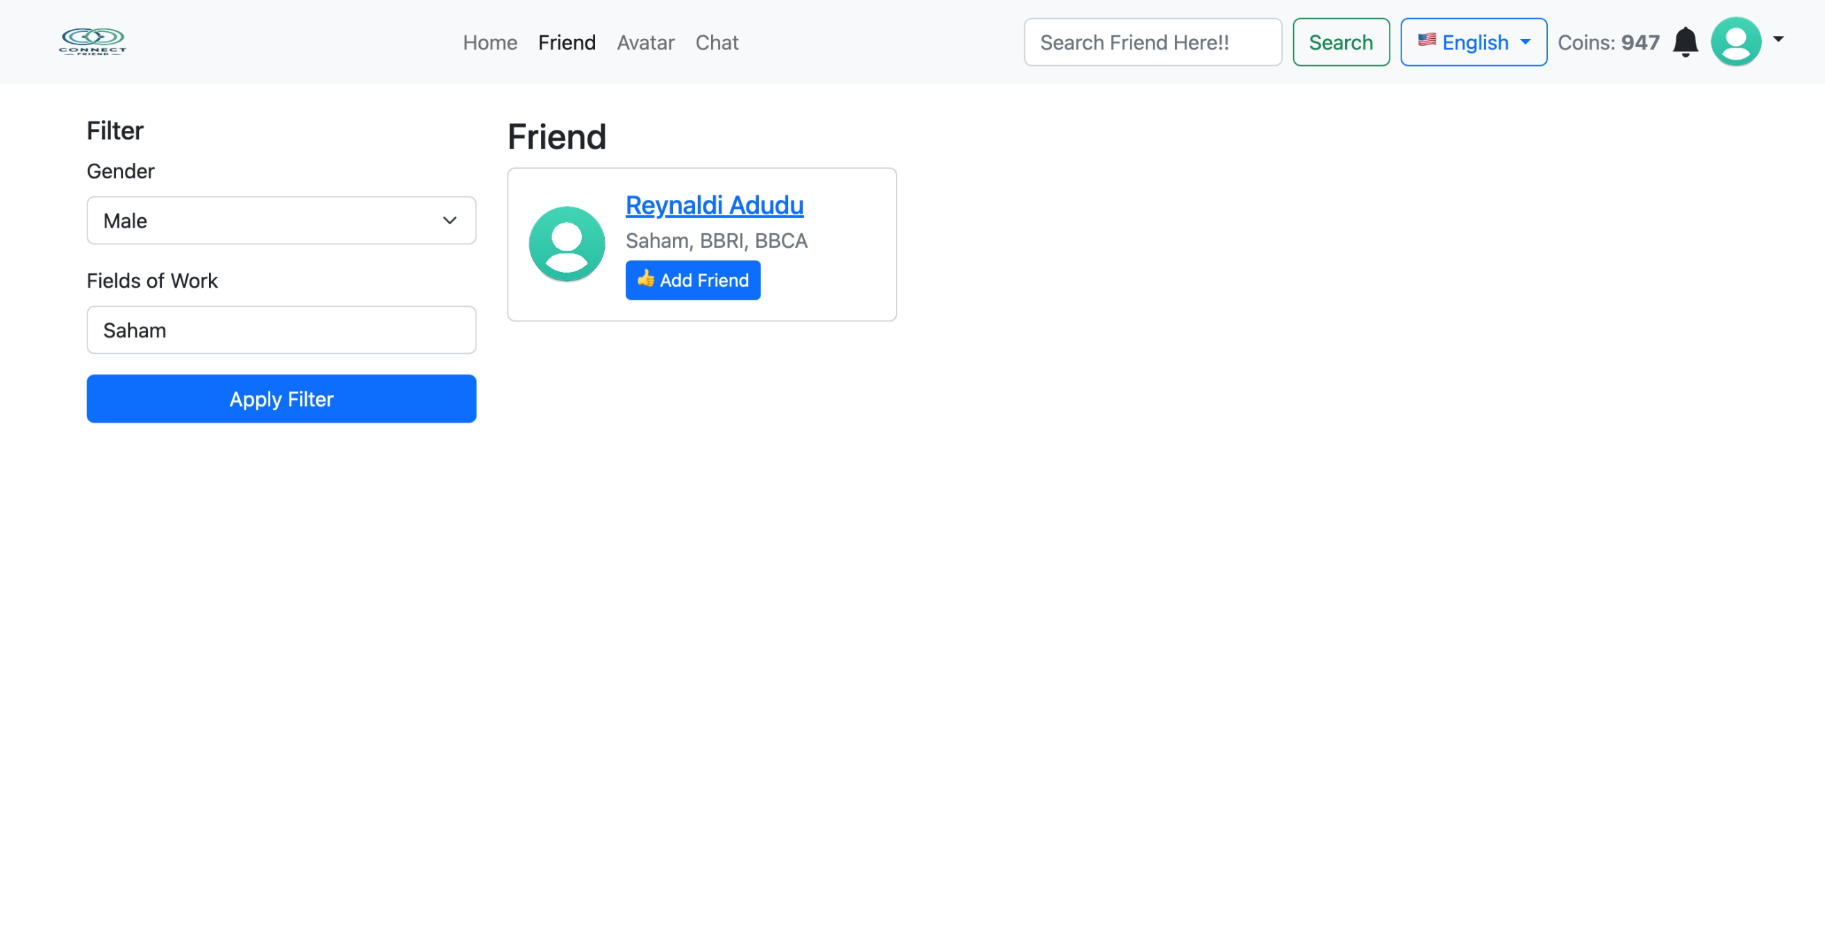

Searching (Name)  
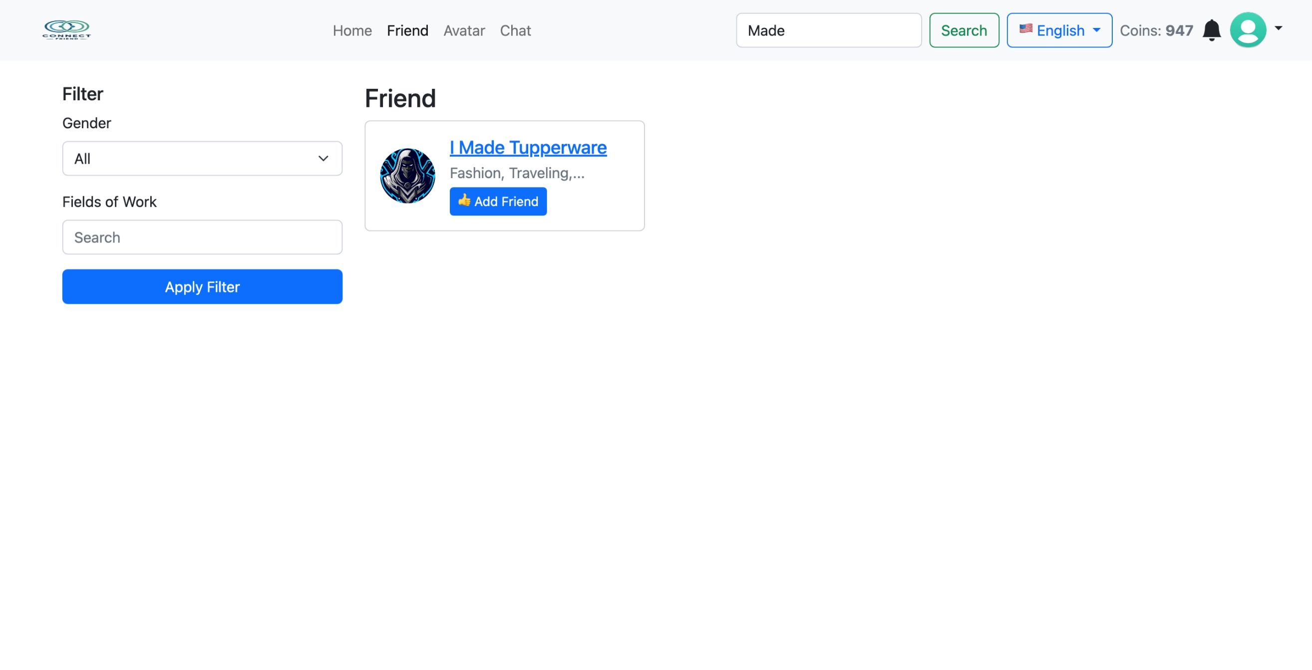

1. **[LO1,LO2,LO3 & LO4,10 points]** Notification

Chat Notification  
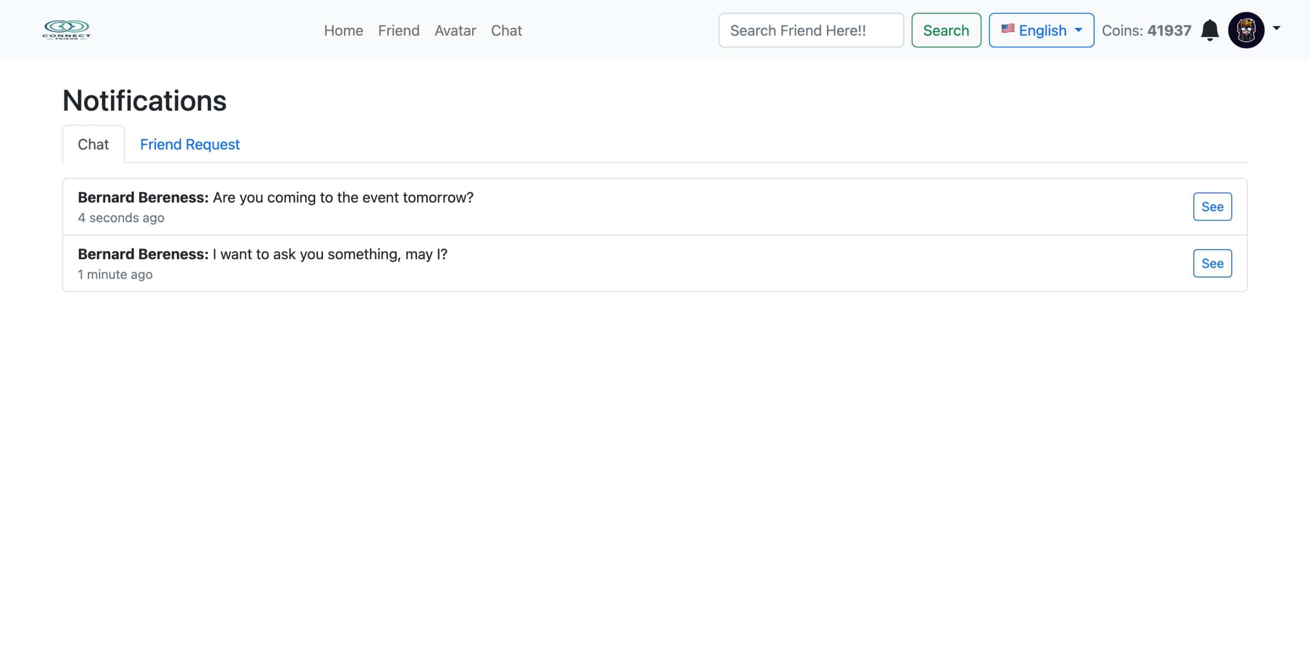

Friend Request Notification  
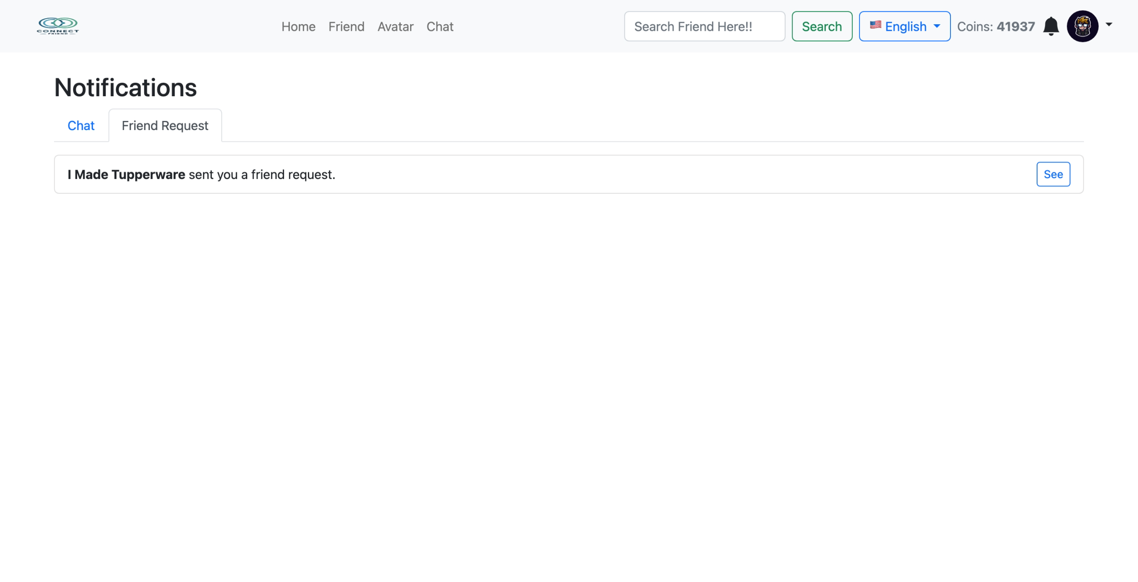

**Additional Features**

1. **LO1,LO2,LO3 & LO4, 30 points]** Buy Avatar

Avatar Market  
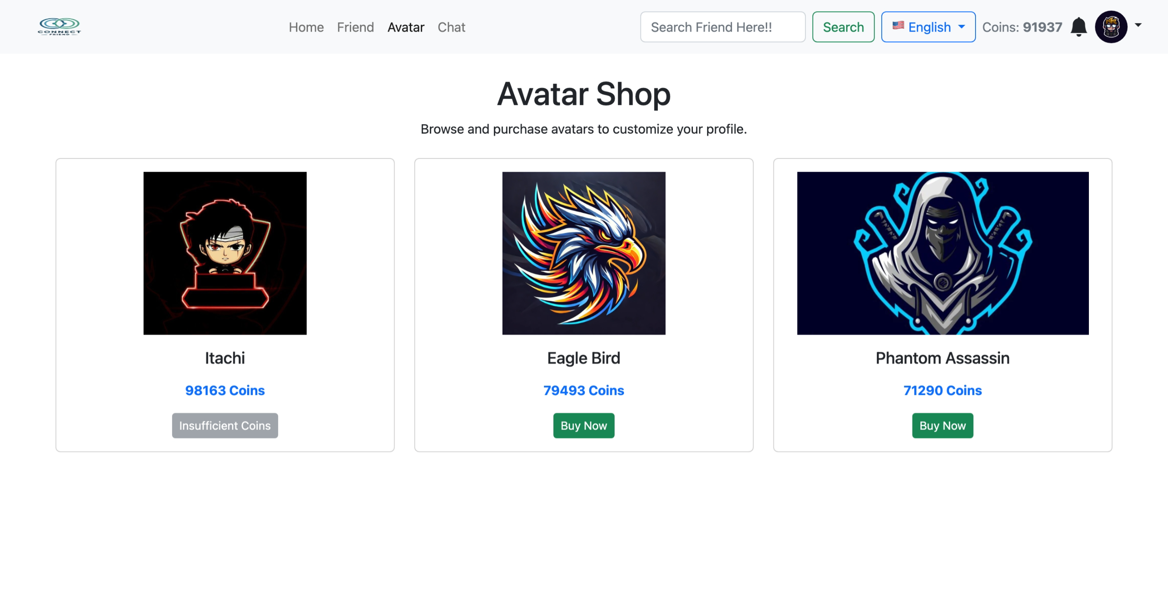

Avatar Profile  
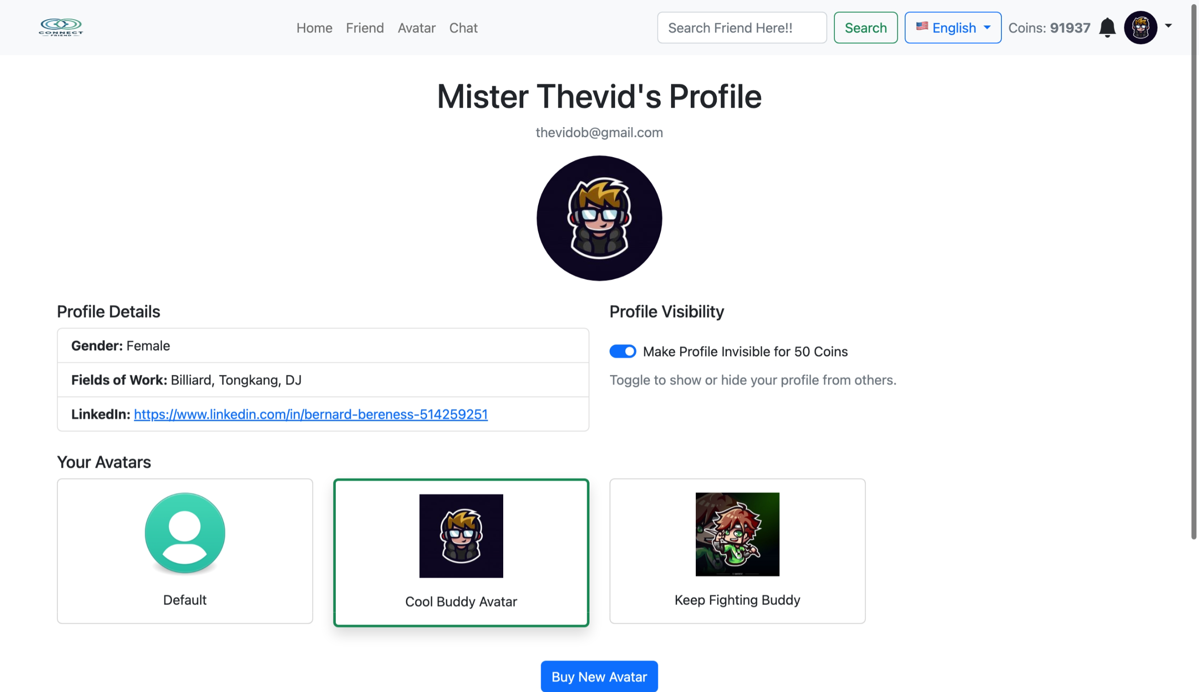

1. **[LO1,LO2,LO3 & LO4, 15 points]** Topup Coins

Topup Coins  
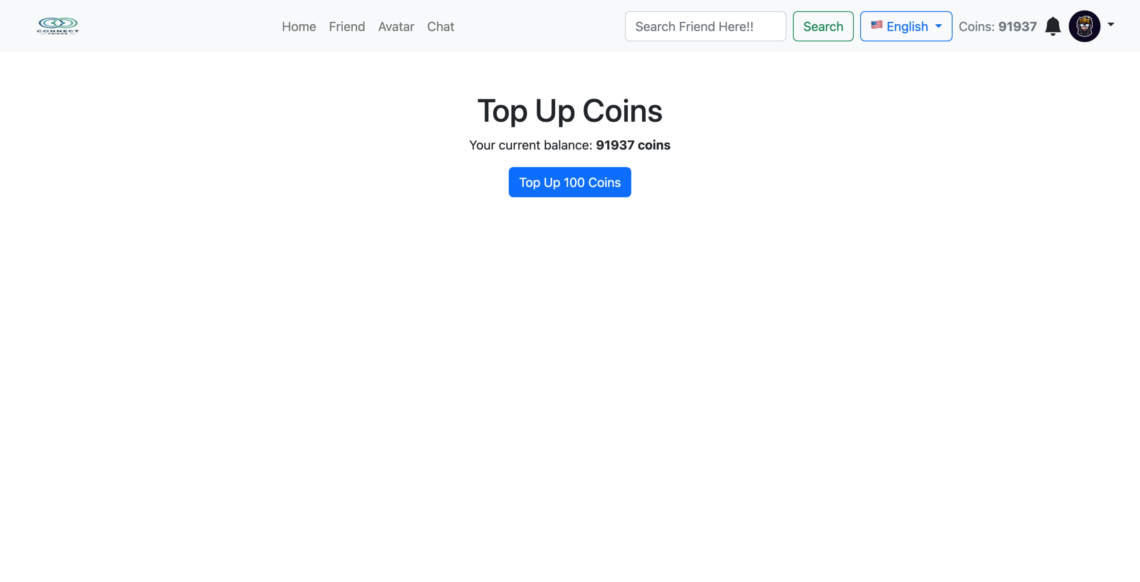

1. **[LO1,LO2,LO3 & LO4, 30 points]** Visible Profile

Visible Profile  
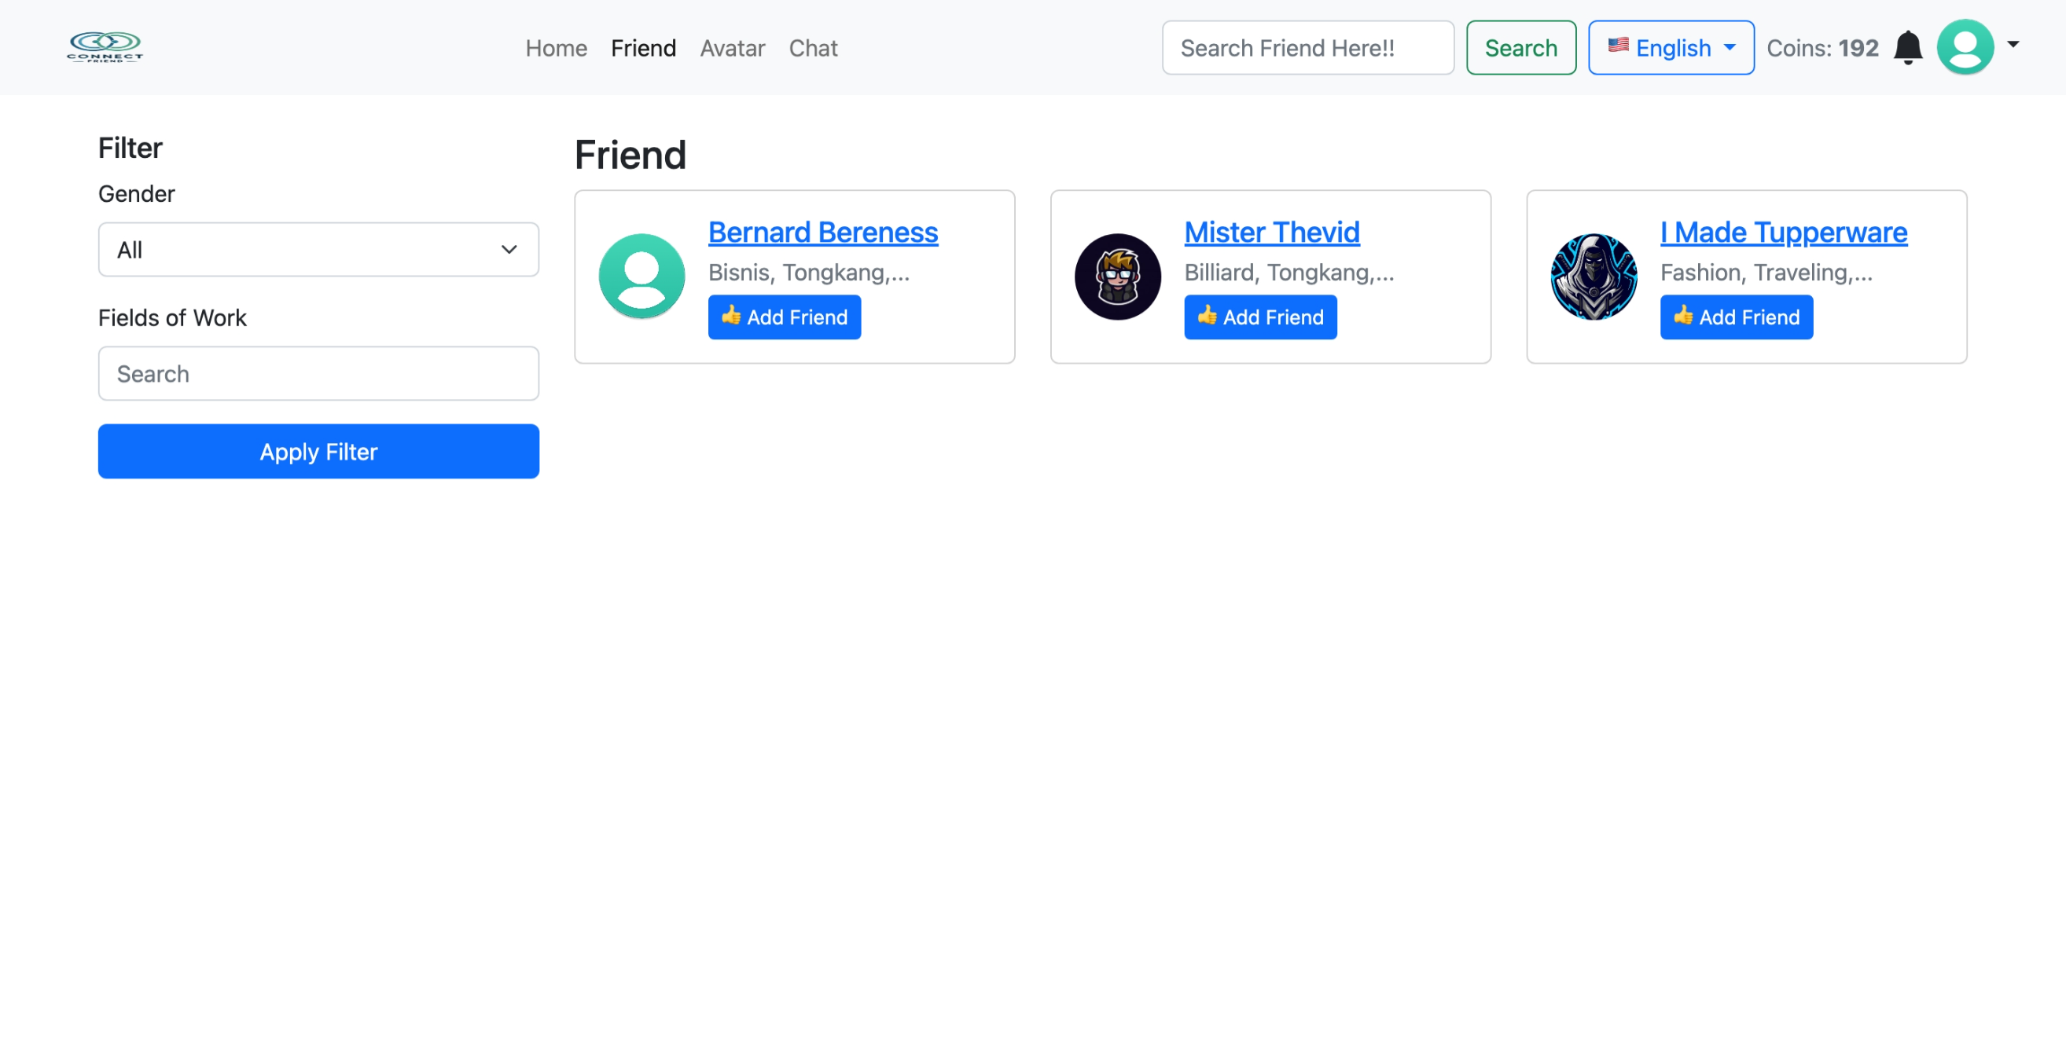

Invisible Profile  
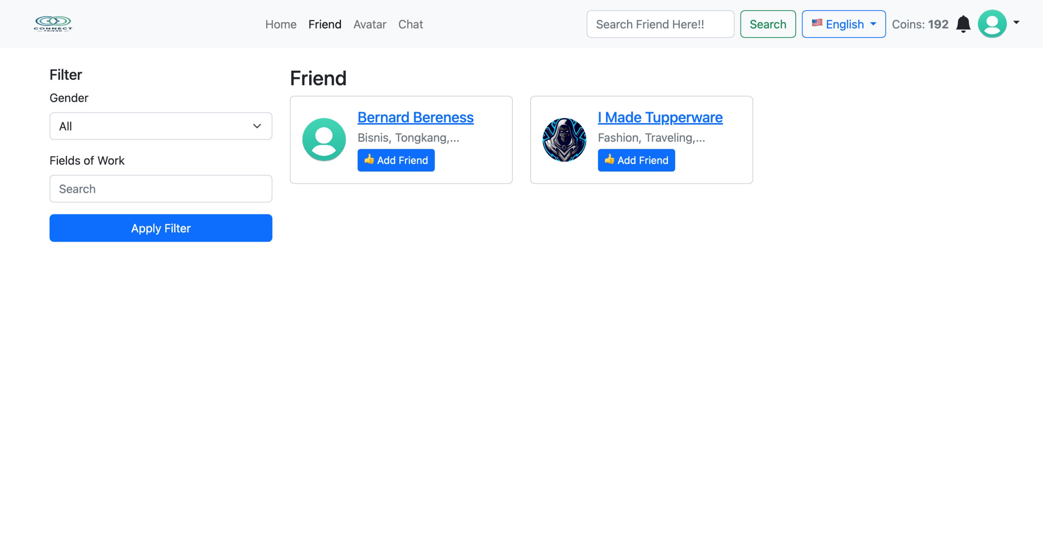  
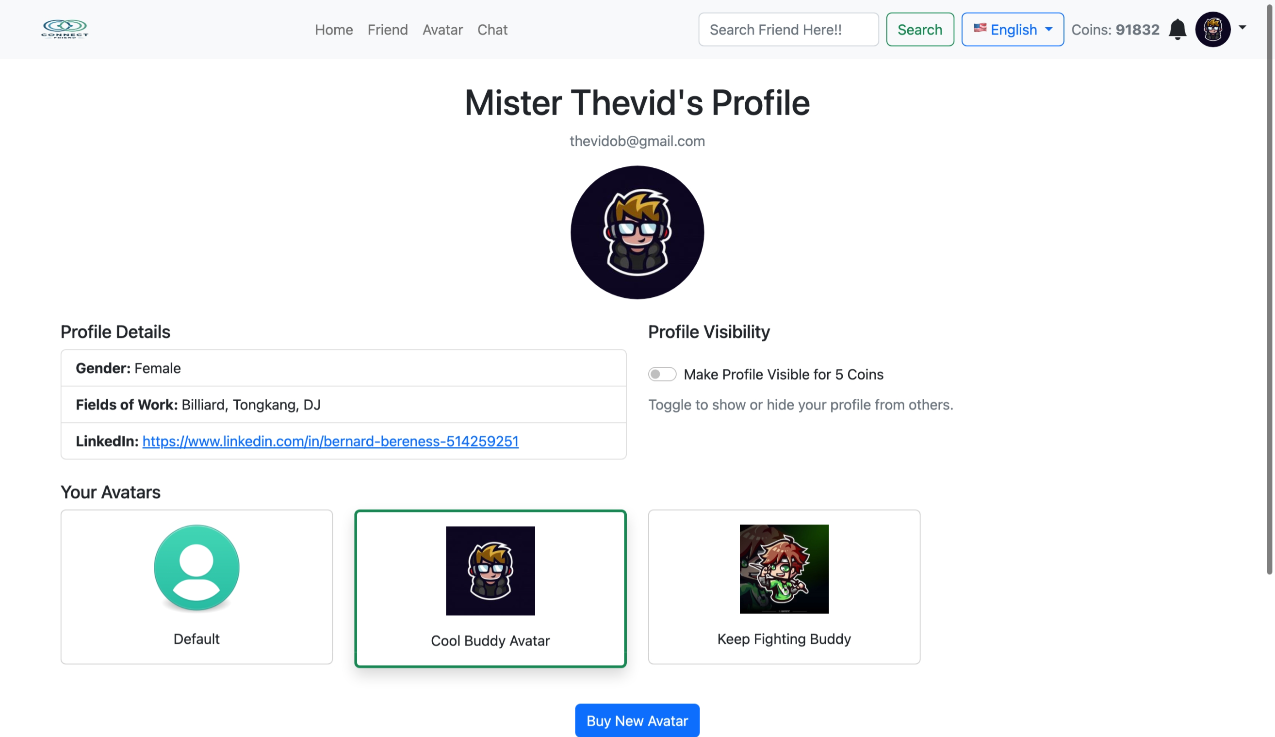

**Localization  
